**Tutorial Arduino Turbidity**

**Oleh: Ardy Seto**

1. Install Arduino IDE - <https://www.arduino.cc/en/main/software>

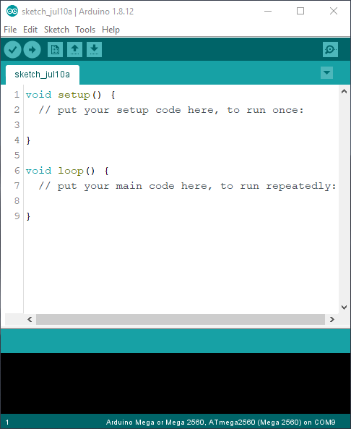

1. Copy library yang digunakan ke Documents/Arduino/libraries

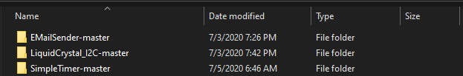

1. Install esp8266 board, tambahkan: <https://arduino.esp8266.com/stable/package_esp8266com_index.json>

Di File – Preferences – Additional Boards Manager URLs klik OK

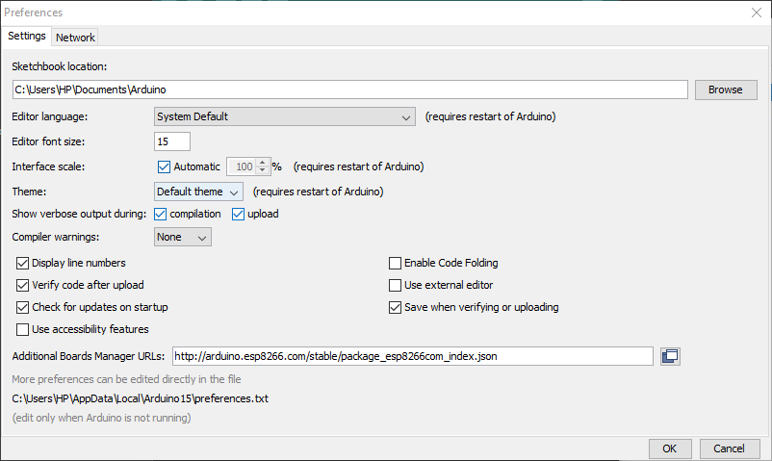

1. Buka Tools – Board manager ketik esp8266 klik install

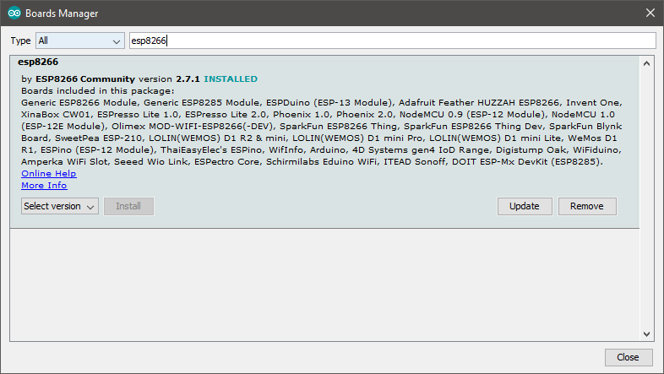

1. Pilih board LOLIN(WEMOS) D1 R2 & Mini

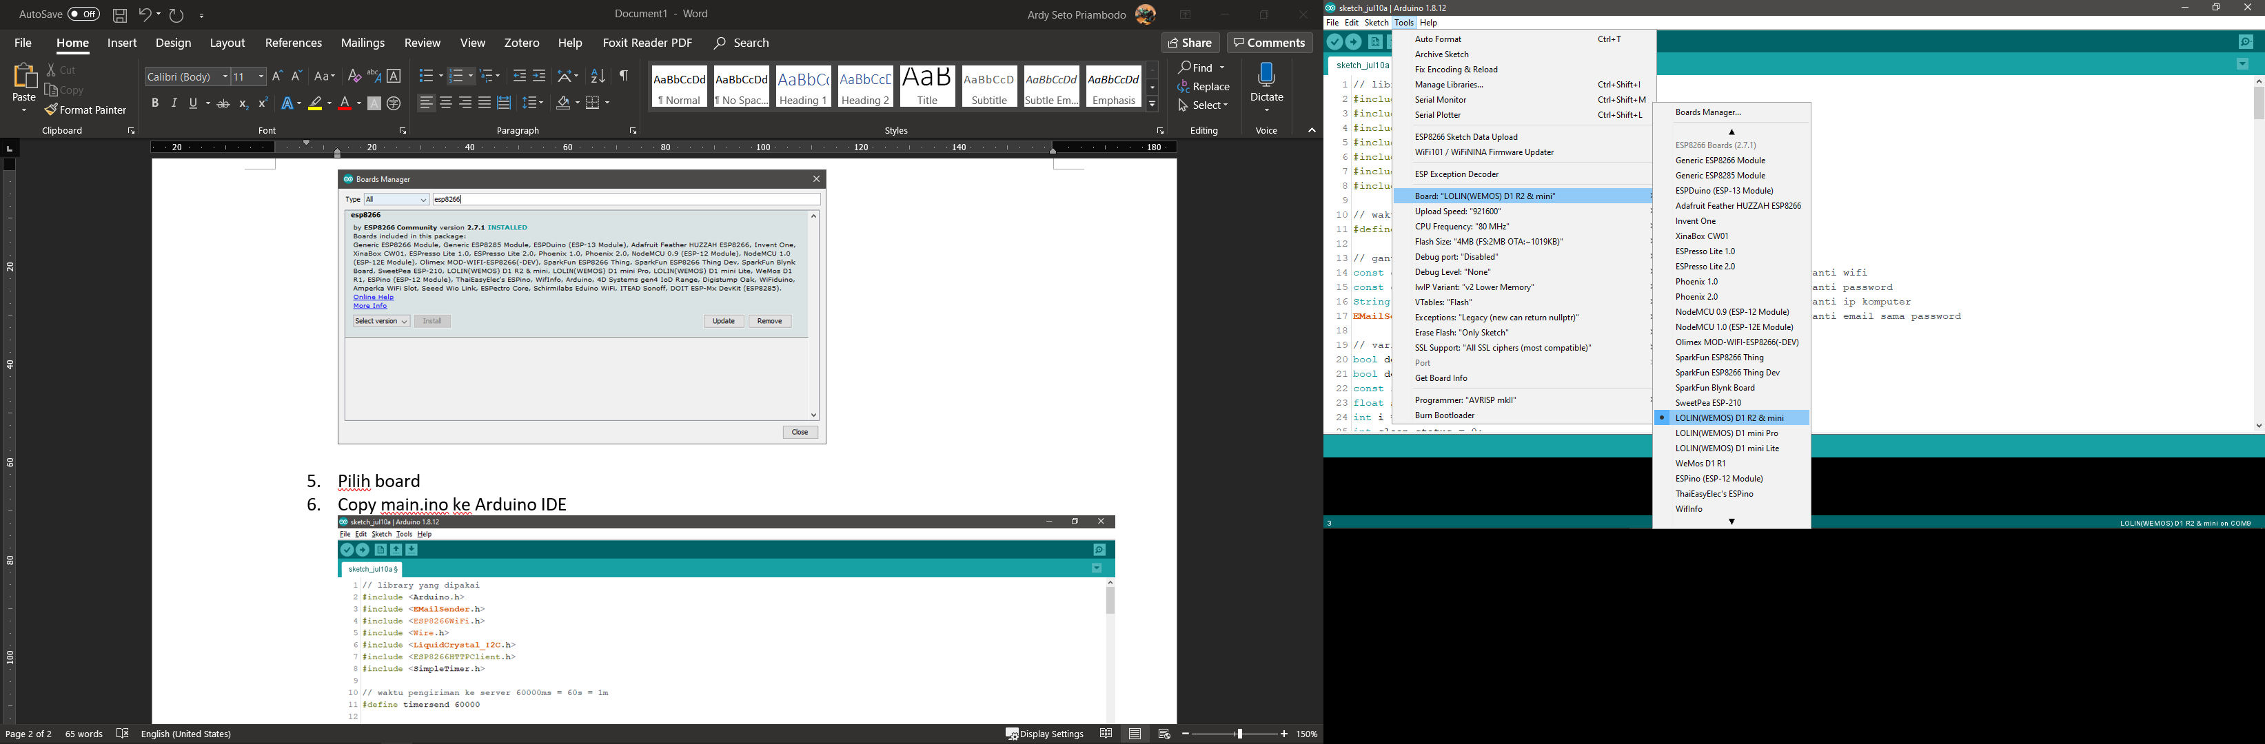

1. Copy main.ino ke Arduino IDE

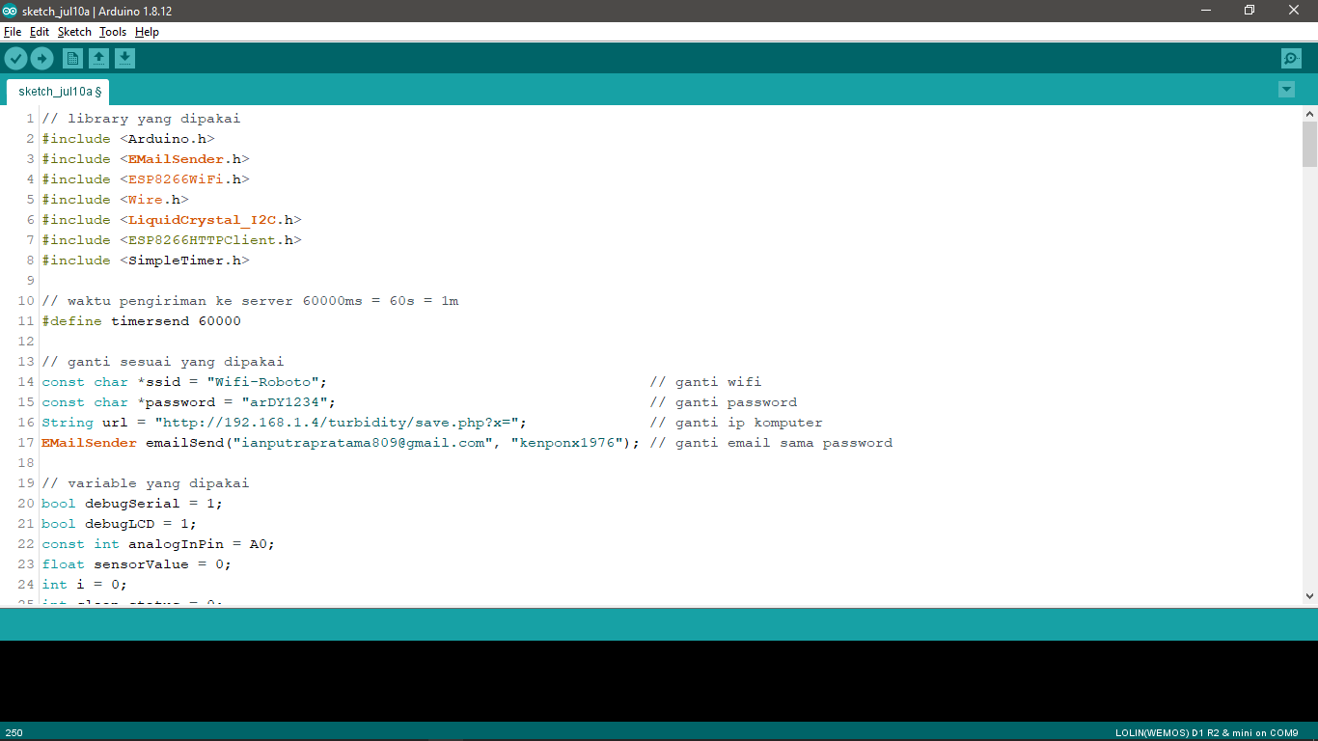

1. Tancapkan usb ke wemos d1 mini dan klik upload untuk upload program

